Art 17 datasets (tabular & spatial)

Sabine Roscher, Jérôme Bailly-Maître, Želmíra Šípková-Gaudillat, Mikaël Baudet Maze, Marita Arvela, Doug Evans, Dominique Richard, Manuel Loehnertz

June 2015

Contents
Introduction 4
1 Overview on the tabular data 5
1.1 Specific case: Data for Greece 6
1.2 Selection of reports for statistics 6
2 The European data set – spatial data (GIS) 8
2.1 Overview on the workflow 8
2.1.1 European data set used for the consultation tool (conservation status as reported by the Member States) 8
2.1.2 European data set final version (conservation status Conservation status at EU biogeographical/marine level) 8
2.2 Data sets used for the production of the European data set 9
2.3 Attributes of the European spatial data set 9
2.4 Sensitive information 10
3 Reference data to facilitate statistics from an ecosystem perspective 11
Annex 1 Methods used to produce EU regional assessments 14
Annex 2 Description of the tables and their attributes 15
Annex 3 Entity-relationship diagram of the EU Art 17 tabular data 29
Annex 4 Correction of species codes for the Greek data 31
Annex 5 Corrections of presence status in the species check list 32
Annex 6 Single rule set for the production of the EU spatial data set 33
Annex 7 Attributes of the European spatial data set 38
Annex 8 Explanation on criteria for the selection of reports and assessments which should be taken into account for statistics on conservation status 40

Introduction
The data sets (tabular data and spatial data) result from the so-called EU biogeographical and marine assessments as well as from the merging selected data reported by Member States under Article 17 of the Habitats Directive into a European database.
Article 11 of this Directive requires Member States to monitor the habitats and species listed in Annexes present in their territory. Under Article 17, Member States have to report every six years, according to a standard format, on the conservation status of all targeted species and habitats occurring in each biogeographical region/ marine region present in that Member State territory.
The European Commission itself will have to report in 2015 on the overall implementation of the Habitats (and the Birds) Directives at the EU level. As part of this, an assessment of the conservation status of targeted species and habitats has been done at the level of each nine biogeographical region and each four marine region of the EU territory.

The current Article 17 reports cover the reporting period 2007-2012; Member States uploaded their reports between June and December 2013 on EIONET Central Data Repository CDR under the obligation “Habitats Directive: Report on Implementation Measures (Article 17, Habitats Directive)”.
The purpose of the European assessments based on these reports is
- to provide the European picture on species and habitats conservation status as part of the second cycle of reporting under Art 17 of the Habitats Directive
- and to provide quantitative elements to assess progress in the implementation of the EU Biodiversity Strategy 2020; specifically on Target 1 of the EU Biodiversity Strategy.
The EU assessments were carried out by the EEA/ETC_BD experts between 7th March and 30th May 2014 followed by a public consultation between 2nd June and 7th July 2014. The data set include the final results from the EU biogeographical and marine assessments.

The following resources are useful to understand the assessments of conservation status at the EU biogeographical level as well as the reporting format and the use of the data:

- Assessments of conservation status at the EU biogeographical level.
This is a background document and ‘user manual’ for the public consultation on the assessments of conservation status.

- Article 17 web tool
This is the web tool used for the biogeographical assessments of the conservation status of species and habitats under Article 17 of the Habitats Directive

- Reference Portal for Article 17 of the Habitats Directive
This web page provides links to all reference documents necessary to fill in the reporting format including Explanatory notes and Guidelines for the period 2007-2012 (reporting guidelines).
- Contextual information for the use of ‘Article 17 data’
Although this document has been created in the context of the previous reporting round (2001-2006) it is still valid and helpful in order to understand the very nature of the data and the appropriate use of the data sets, in particular the spatial datasets.

The purpose of this note is to document the structure of the EU Article 17 datasets covering both tabular and spatial data.

Overview on the tabular data
In order to ‘package’ a useful Art17 data set the following data elements have been chosen for this delivery:

- Data on Member States level
  - Data presented in the assessment tool and used by the experts as basis for the European assessment
- Subset of the data reported by Member States
- Overall conservation status (CS) as reported by MS in the previous reporting period and the nature of change in CS between the two reporting periods as reported by MS in the current reporting period
- Area calculations from the GIS data set on distribution and range
  - Data not presented in the assessment tool but considered as relevant for other kinds of analysis carried out on the basis of data reported by Member States
- Threats and pressures
- Conservation measures
- Natura 2000 coverage
- Typical species
- Species and habitats checklist, including cross linkage of species names used by Member States and the species names used for the European level as well as the information in which Annexes of the Habitats Directive the species and habitats are listed.

- Data on European level (EU27)
  - Data presented in the assessment tool resulting from expert assessment and subsequent consultation phase
- Data calculated based on the data reported by MS using the appropriate method as selected by the experts
- Overall conservation status (CS) from the previous reporting period and nature of change in CS between the two reporting periods as assessed by the experts
- Contribution to Target 1 of the European Biodiversity Strategy as assessed by the experts

The detailed listing of all tables and their content is in Annex 2. Where the data result directly from the reports delivered by the Member States this Annex provides the mapping for each table attribute to the corresponding section in the reporting format. An overview on the methods used to produce EU regional assessments is given in Annex 1. More information on the assessments of conservation status at the EU biogeographical level can be found in the ETC/BD Technical paper 3/2014.

Figure 1-1 shows the main data elements in the assessment web tool, which inform on selected information provided by Member States and the conclusions drawn by the experts for the European biogeographical level.
The schema in Figure 1-2 shows the data base tables. “Species regions MS level” corresponds to the table “data_species_regions_MS” which contains data reported by Member States on a species within a biogeographical or marine region such as conservation status. The entity “Pressures & Threats” corresponds to a table with information on pressures and threats reported by Member States for species or habitat types within a biogeographical or marine region. For the European level “Species regions EU level” contains information resulting from the EU biogeographical and marine assessments. The “checklist” provides inter alia information on how the species names used in the national reports are cross-linked to the species names which are used for the European assessment.

The entity-relationships are described in Annex 3. Please note: Depending on the purpose of the query the predefined joins in the MS Access relationship tool should not be used. In example if the number of pressures reported by Member States is counted, then the relation between the checklist and the table pressures should be joined (strict join) using the regionhash (see query “reported_pressures_and qualifiers_for_habitats_MS_level”).

Specific case: Data for Greece
As Greece did not deliver a report in 2013, the data for this Member State have been taken from the previous reporting round where feasible. The fields for which the import was not possible are:
- Threats and pressures (Reason: conceptual changes in the code list for threats and pressures used in the current reporting format)
- Natura 2000 (Reason: this section on Natura 2000 was not part of the format in the previous reporting round)
Furthermore species codes had to be changed and misspellings of species named were corrected (see Annex 4).

It is expected that Greece will deliver a report by the end of 2014. However this will not influence anymore the European assessments for the Biogeographical regions for this reporting round.

Selection of reports for statistics
Depending on the purpose of the statistics certain habitats and species reports should not be taken into account in order to generate useful information. E.g. the Member States reports for ‘occasional’ and ‘newly arriving’ species in terrestrial biogeographical region should only be included in the statistics if they contain the assessment of conservation status and if the occurrence of the species in the region is significant. Another example are the Member States reports for occasional species in marine regions. They should be excluded as available information does not allow distinguishing between situations where the conservation status is not assessed due to incomplete data or the assessment is impossible due to irregular occurrence of a species.

Reports that should be excluded for the statistics are indicated with “use_for_statistics = no” in the tables species_regions_MS_level, habitats_regions_MS_level, species_regions_EU_level and habitats_regions_EU_level.

Figure 1-1 Overview on data elements in the assessment tool
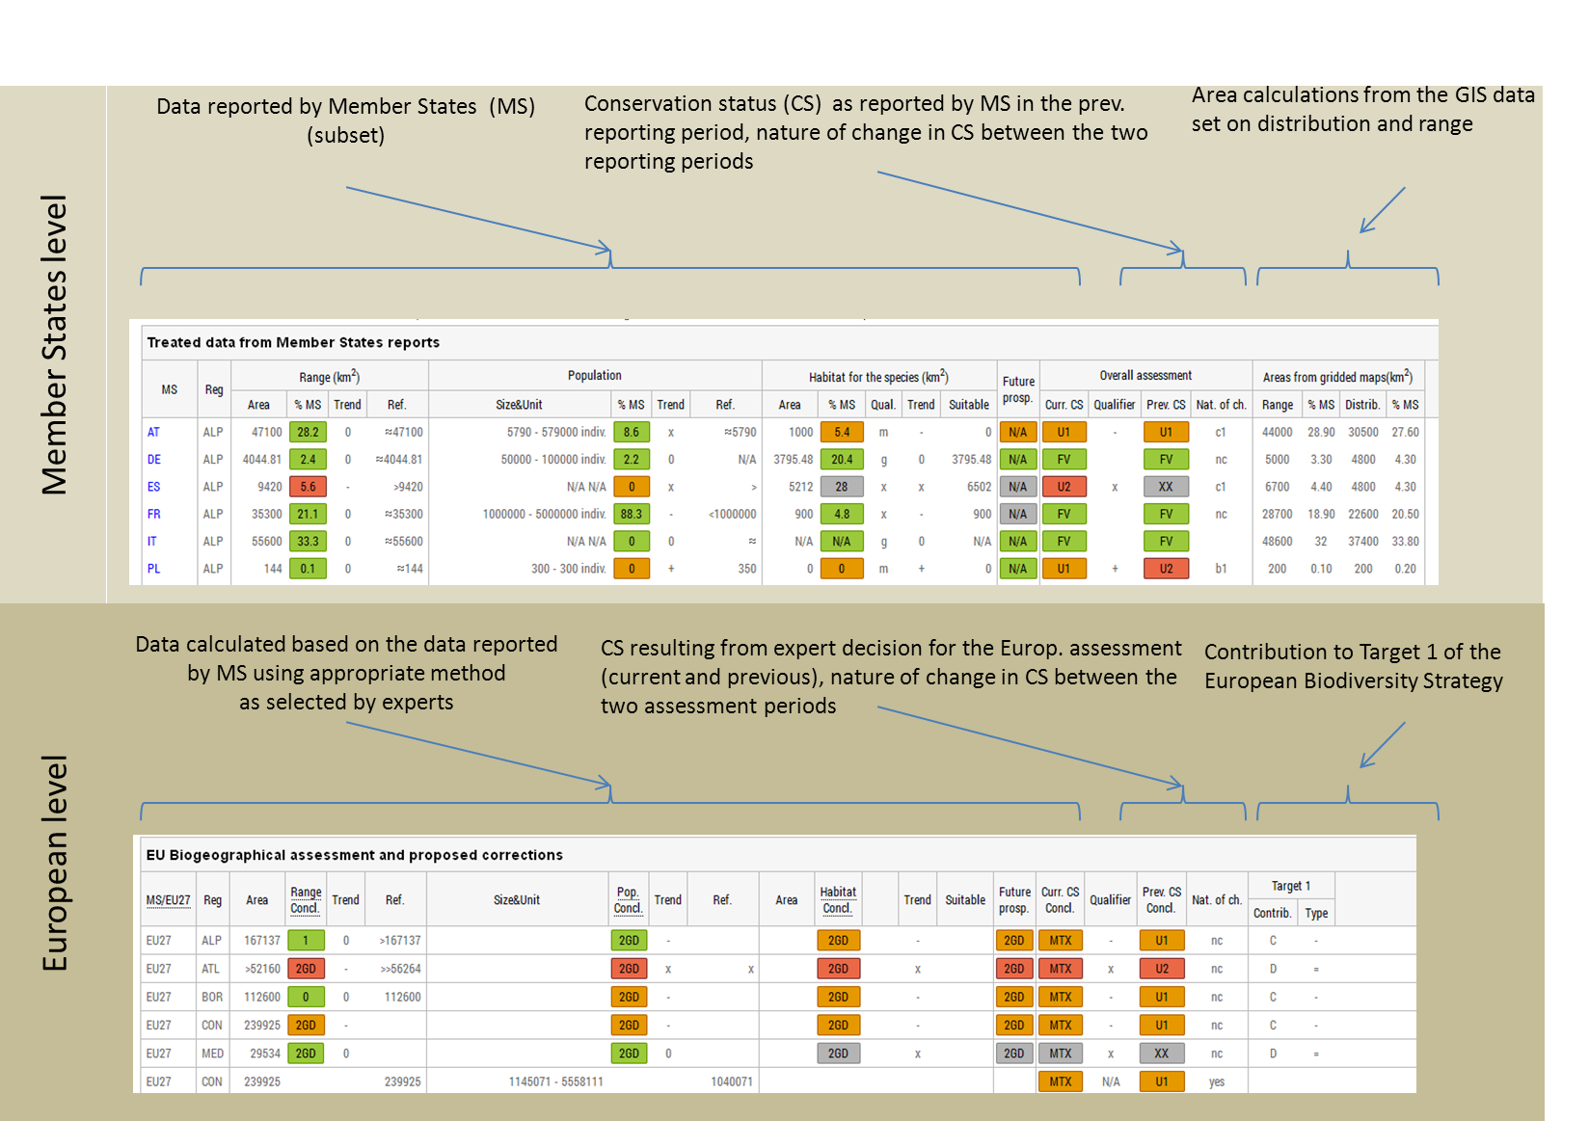

Figure 1-1 Schematic overview on data structure
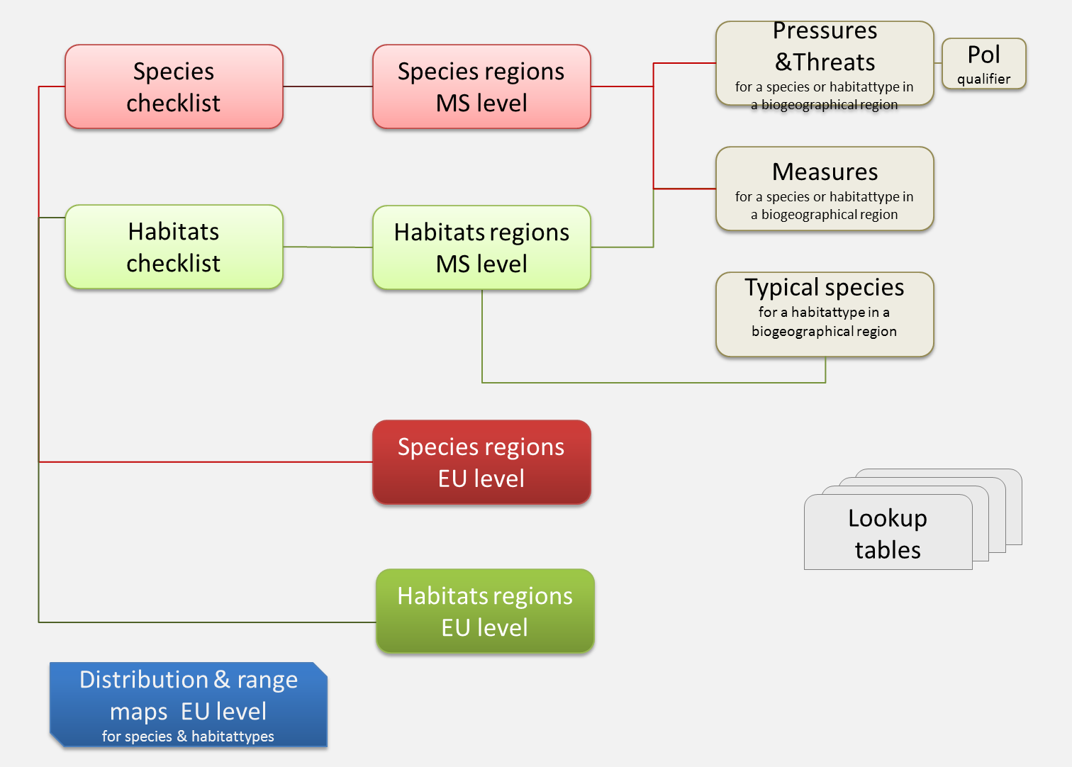

The European data set – spatial data (GIS)

Overview on the workflow

European data set used for the consultation tool (conservation status as reported by the Member States)
An overview on the workflow for the production of the GIS data set is given in figure 2-1.
The distribution and range maps as delivered by the Member States have been merged into a European data set. The overlapping cells – e.g. along country borders and boundaries between biogeographical and marine regions – have been treated according to a detailed rule set as described in Annex 6.
For this purpose the conservation status reported by the Member States for each species and habitat type in the biogeographical and marine region was transferred from the tabular data into the spatial data set by means of the rules as described in Annex 6.
The purpose of these maps was to support the assessment of the conservation status at the European level.

European data set final version (conservation status Conservation status at EU biogeographical/marine level)
The final European GIS data set contains the conservation status of species and habitat types for each of the biogeographical and marine regions for the European level. These values have been transferred from the tabular data into the spatial data. In addition the conservation status for the Member States level was kept for each grid cell from the data set which was used for the consultation tool.

Figure 2-2 Overview on the production of the final version of the EU GIS data set
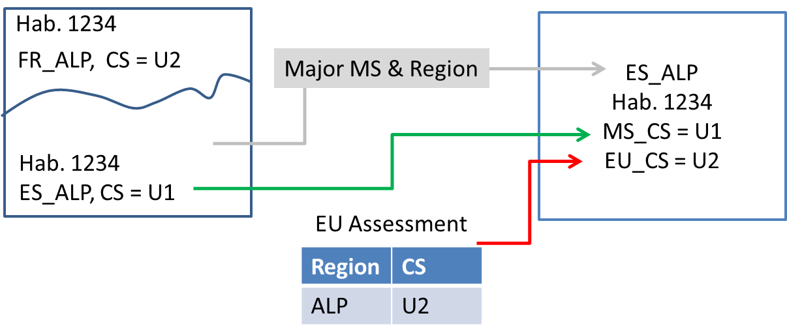

Data sets used for the production of the European data set
- Distribution and range maps for species and habitat types delivered by the Member States (the links to the reports are listed in Annex 2)

- EuroBoundaryMap (full European coverage) - version 7.0, Oct. 2013
http://sdi.eea.europa.eu/catalogue/srv/eng/search?uuid=f917855c-8fde-44dd-99f1-7849060e1844

- Exclusive Economic Zones (EEZ) of the world - version 7, Nov. 2012
http://sdi.eea.europa.eu/catalogue/srv/eng/search?uuid=7e5f9e9b-5cbe-477b-8244-7bba236033ea

- Biogeographical regions, Europe 2011
http://sdi.eea.europa.eu/catalogue/srv/eng/search?uuid=5e884531-3b0e-4643-af14-ae6281d6fb24

- MSFD provisional dataset on sea regions and sub-regions - INTERNAL VERSION, Sep. 2013
https://sdi.eea.europa.eu/internal-catalogue/srv/eng/search?uuid=81197a77-db68-49c4-8678-1fdd2acc41dc

Attributes of the European spatial data set
The spatial data have in addition to the standard attributes such as CellCode or EofOrigin also information on the biogeographical or marine region and the conservation status (for both the European level and the Member State level). These attributes have been transferred from the tabular data into the spatial data following the rules as described in Annex 6. A detailed description of the attributes of all spatial data sets can be found in Annex 7. Table 2-1 shows the attributes by the example of the habitats distribution.

Table 2-1 Description of the attributes of the spatial data set for habitats distribution.
Attribute | Type | Example | Comment
CellCode | String | 10kmE429N265 | EEA 10 km grid code (ETRS3035)
EofOrigin | Number | 4290000 | East [m]
NofOrigin | Number | 2650000 | North [m]
GRIDS_CS | String | 10x10LAEA | Source GRID size
CATEGORY | String | Habitat | Habitat
MAPTYPE | String | Distribution | Maptype = DISTRIBUTION
CODE | String | 1170 | Art17 habitat CODE
MS | String | AT | Member state
Region | String | MATL | Biogeographical regions
CS_MS | String | FV | Conservation status by Member State
CS_EU27 | String | U2 | Conservation status by EU27
AREA_ha | Number | 10000 | Area in [ha]

Sensitive information
Table 2-2 Number of 'sensitive species'
AT | 1 |  | LU | 4
CY | 1 |  | LV | 3
DE | 15 |  | MT | 3
FI | 12 |  | PL | 1
IT | 1 |  | PT | 34

Some Member States considered that for selected species making information on their distribution publicly available is detrimental to their conservation (guidance on sensitive species was given in the reporting guidelines).
The reporting format allowed flagging those species. Thus the distribution maps for species being marked as sensitive information have been removed from the European spatial data set.

Reference data to facilitate statistics from an ecosystem perspective
For reporting on state and trends of biodiversity from an ecosystem perspective, information on the association of species and habitat types to ecosystems is required. Hence in 2013 the ETC/BD prepared reference data sets - building on preliminary work done in 2010 -, where all Mammal, Reptile and Amphibian species listed in European Atlases, all species and habitats considered for reporting under Article 17 of the Habitats Directive and all bird species considered for reporting under Article 12 of the Birds Directive are allocated to ecosystem-types as defined by the MAES typology (under Target 2 of the EU 2020 Biodiversity Strategy). This allocation of species and habitat per ecosystem is done for each of the nine terrestrial biogeographical regions (according to the Habitats Directive) and each marine region (according to the Marine Strategic Framework Directive). The methodology is described in: EEA 2013: Linking species and habitats with MAES ecosystem types at biogeographical level. Explanatory note. This note was prepared for the public consultation in 2013.
The “MAES tables for species and habitats” is part of the reference data set on “association of species and habitat types to ecosystems” and includes all habitat types covered by the Habitats Directive and all species listed in Annex II,IV and V of the Habitats Directive with the exeption of the genera Lycopodium, Spagnum and Cladonia. Also some amphibians, reptiles, mammals and butterflies from published European Atlases are included. The association between species and ecosystems is indicated using the three categories: preferred ecosystem, suitable ecosystem and occasional ecosystem. Table 3-1 shows the rules which were applied for the allocation of species and habitat types to ecosystems.

Table 3-1 Rules for the allocation of species and habitat types to ecosystems
Categories used
P | Preferred ecosystem
S | Suitable ecosystem
O | Occasional ecosystem
Rules applied
Habitat types | - Terrestrial habitat types: only 1 preferred ecosystem  - Marine habitat types: due to the complexity of marine environment, in some cases, several ecosystems have been attributed for one habitat type
Species | - Terrestrial/freshwater species: max. of 2 preferred  - Marine species: max. 3 preferred  - Non avian species: several ‘S’ and ‘O’

Table 3-3 Description of the MAES table for habitats
Table: habitats_maes | Explanation
Table attribute
id | Auto generated unique identifier
region | Biogeographical or marine region, lookup table: lu_biogeoreg
codeeco | Code ecosystems, see lookup table: lu_ecosystems_maes
habitatcode | Code Habitats Directive habitat type
description | Description Habitats Directive habitat type

Table 3-4 Description of the MAES table for species
Table: species_maes | Explanation
Table attribute
id | Auto generated unique identifier
region | Biogeographical or marine region, lookup table: lu_biogeoreg
codeeco | Code ecosystems, see lookup table: lu_ecosystems_maes
speciesname | Species name
typeasso | Importance of the species relation/link to the MAES classification: lu_spec_hab_association
assessment_speciesname | Species name according to the Annexes of the Habitats Directive
speciesgroup | Higher taxonomic group (simplified)
HD_name | Species name according to the Annexes of the Habitats Directive

References
Reference Portal: http://bd.eionet.europa.eu/activities/Reporting/Article_17/reference_portal
Explanatory notes and guidelines for Article 17 reporting: https://circabc.europa.eu/w/browse/0de47902-0a08-41dd-943c-520066a3c529
EEA-ETC/BD (2013): Information note on the content and characteristics of the EU Article 17 data - Descriptive and spatial databases for the period 2001-2006 http://www.eea.europa.eu/data-and-maps/data/article-17-database-habitats-directive-92-43-eec#tab-additional-information
ETC/BD Technical paper 3/2014: Article 17 Reporting. Assessments of conservation status at the EU biogeographical level. Public consultation. ETC/BD
http://bd.eionet.europa.eu/activities/Reporting/Article_17/Documents/ART17%20public%20consultation%20guide.pdf

Methods used to produce EU regional assessments

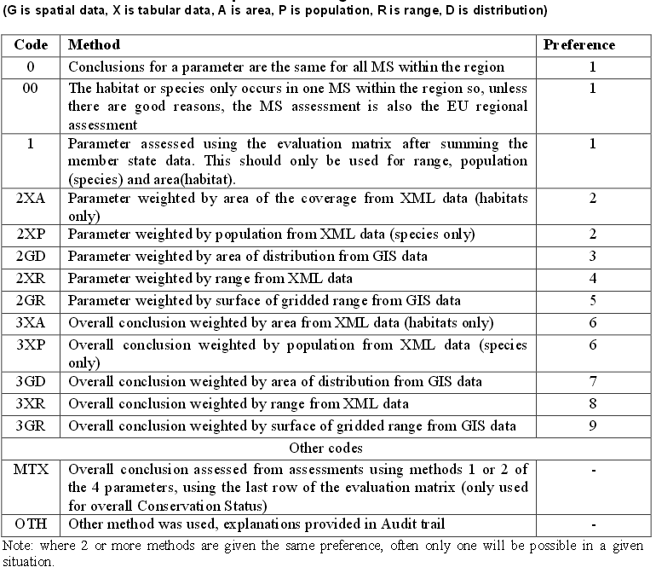

Description of the tables and their attributes

Please note: For all table attributes which correspond to data delivered by the Member States a reference is given to the particular section in the reporting format (see columns “Field number” and “Field name”). For other table attributes a brief description is given in the column “Explanation”.

General report

Reporting format |  | Table: data_greport | Explanation
Field Number | Field Name | Table attribute
 |  | greporthash | General report auto generated primary key
0 | Member State | country | 2-letter ISO country code
1.1 | Text in national language | achievements | Text in national language
1.2 | Translation into English | achievements_trans | English translation
2.1 | General information on the Habitats Directive | general_information | General information about the Habitats Directive
2.2 | Information on the Natura 2000 network in the Member State | information_on_network | Information about the Natura 2000 network
2.3 | Monitoring schemes (Art 11) | monitoring_schemes | Monitoring schemes (Article 11)
2.4 | Protection of species (Art 12-16) | protection_of_species | Protection of species (Articles 12-16)
2.5 | Transposing of the Directive (legal texts) | transpose_directive | Transposition of the Habitats Directive (legal texts)
3.1a | All sites – number of pSCIs, SCIs, SACs | sites_total_number | Total number of pSCIs, SCIs, SACs
3.1b | All sites – area of pSCIs, SCIs, SACs | sites_total_area | Total surface area of pSCIs, SCIs, SACs (km²)
3.1c | All sites – number of SACs | sac_total_number | Total number of SACs
3.1d | All sites – area of SACs | sac_total_area | Total surface area of SACs (km²)
3.1.1a | Terrestrial area of sites (excluding marine areas) – area of pSCIs, SCIs, SACs | sites_terrestrial_area | Surface area of pSCIs, SCIs, SACs (km²) in terrestrial area of sites (excluding marine areas)
3.1.1b | Terrestrial area of sites (excluding marine areas) – area of SACs | sac_terrestrial_area | Surface area of SACs (km²) in terrestrial area of sites (excluding marine areas)
3.1.2a | Marine area of sites – number of pSCIs, SCIs, SACs | sites_marine_number | Number of pSCIs, SCIs, SACs in marine area of sites
3.1.2b | Marine area of sites – area of pSCIs, SCIs, SACs | sites_marine_area | Surface area of pSCIs, SCIs, SACs (km²) in marine area of sites
3.1.2c | Marine area of sites – number of SACs | sac_marine_number | Number SACs in marine area of sites
3.1.2d | Marine area of sites – area of SACs | sac_marine_area | Surface area of SACs only (km²) in marine area of sites
3.2 | Date of database used | database_date | Date of latest update of the Natura 2000 database sent to the Commission
4.1 | Number of sites for which management plans have been adopted | sites_with_plans | Number of sites with management plans
4.2 | % of the network area covered by management plans | coverage | Percentage of the network area covered by management plans
4.3 | Number of sites for which management plans are under preparation | plans_under_prep | Number of sites with management plans under preparation
6 | Measures taken to ensure coherence of the Natura 2000 network | coherence_measures | General description of the main measures taken to ensure coherence of the Natura 2000 Network (Article 10)

General report – reintroduction of Annex IV species

Reporting format |  | Table: data_greintroduction_of_species | Explanation
Field Number | Field Name | Table attribute
 |  | greporthash | Foreign key to data_bgreport
7.1.0b | Species name and code – code | speciescode | Species code ; Codelist: lu_hd_species
7.1.0a | Species name and code – name | speciesname | Name of the species as reported by the Member State
 |  | reintro_period_since | Qualifier: '=' in the year; '<' before the year; '>' after the year given in field reintro_period
7.1.1 | Reintroduction period | reintro_period | Reintroduction period
7.1.2 | Reintroduction location and number of individuals reintroduced | location_number | Reintroduction location and number of individuals reintroduced
7.1.3 | Is the reintroduction successful? | successful | Indicates if natural reproduction has already taken place and/or population is growing
7.1.4 | Additional information on the reintroduction | additional_information | Additional information on the reintroduction

General report – compensation measures

Reporting format |  | Table: data_gmeasures | Explanation
Field Number | Field Name | Table attribute
 |  | greporthash | Foreign key to data_bgreport
5.1.1 | Site code | sitecode | Site code
5.1.2 | Site name | sitename | Site name
5.1.3 | Year of project/plan | project_year | Year of project/plan
5.1.4 | Title of project/plan | project_title | Title of project/plan
5.1.5 | Commission opinion requested ? | commission_opinion | Commission opinion requested?
5.1.6 | Impact of projects in need of compensation measures on conservation status? | project_impact | Impact of projects in need of compensation measures on conservation status?

Species regions EU level

Table: data_species_regions_EU_level | Explanation
Table attribute
country | Default value EU27. Codelist: lu_countries
region | Code of the biogeographical or marine region (codelist: lu_biogeoreg)
assessment_speciescode | Species code corresponding to the assessment_speciesname
assessment_speciesname | Name of the species used for the European assessment
range_surface_area | Surface area of the range in km². (concatenation of number and qualifier, codelist: lu_favourable_range_operator)
range_trend | Trend of the range (codelist: lu_trends)
complementary_favourable_range | Favourable reference range in km². (concatenation of number and qualifier, codelist: lu_favourable_range_operator)
population_size | Size of the population. (concatenation of number and qualifier, codelist: lu_favourable_range_operator)
population_size_unit | Units used for the population size (codelist: lu_population_units)
population_trend | Trend of the population (codelist: lu_trends)
complementary_favourable_population | Favourable reference population. (concatenation of number and qualifier, codelist: lu_favourable_range_operator)
habitat_surface_area | Surface area of the habitat for the species in km². (concatenation of number and qualifier, codelist: lu_favourable_range_operator)
habitat_trend | Trend of the area of the habitat of species (codelist: lu_trends)
complementary_suitable_habitat | Area of the suitable habitat for the species in km² (concat. of number and qualifier, codelist: lu_favourable_range_operator)
method_range | Code of the method used to assess the range at the biogeographical level. Codelist: lu_assessments_method
conclusion_range | Conclusion - range (codelist: lu_assessments)
method_population | Code of the method used to assess the population of the species at the biogeographical level. Codelist: lu_assessments_method
conclusion_population | Conclusion - population. Codelist: lu_assessments
method_habitat | Code of the method used to assess the habitat of the species at the biogeographical level. Codelist: lu_assessments_method
conclusion_habitat | Conclusion - habitat. Codelist: lu_assessments
method_future | Code of the method used to assess the future prospects. Codelist: lu_assessments_method
conclusion_future | Conclusion - future prospects. Codelist: lu_assessments
method_assessment | Code of the method used to calculate the overall assessment. Codelist: lu_assessments_method
conclusion_assessment | Overall assessment (codelist: lu_assessments)
conclusion_assessment_trend | Overall trend in conservation status (codelist: lu_trends_conclusion)
conclusion_assessment_prev | Overall assessment from the previous reporting round 2001-2006 (codelist: lu_assessments)
conclusion_assessment_change | Coded values for the nature of change in the overall assessments between the previous and current reporting (codelist: lu_natureofchange)
type_target1 | Evaluation of progress to Target 1 of the EU Biodiversity Strategy (=) no change, (+) improvement, (-) deterioration, (x) not known (codelist: lu_assessments)
contribution_target1 | Type of change in the conservation status between reporting periods ‘(A) favourable, (B) improved, (C) deteriorated,  (D) unfavourable or unknown assessments that did not change, (E) assessments that became unknown (codelist: lu_assessments)
use_for_statistics | Depending on the purpose of the statistics certain habitats and species reports need to be excluded from the analysis in order to generate useful information. This field can be used to quickly identify the records to keep/exclude.

Habitats regions EU level

Table: data_species_regions_EU_level | Explanation
Table attribute
country | Default value EU27. Codelist: lu_countries
region | Code of the biogeographical or marine region
habitatcode | Code of the habitat type Annex I Habitats Directive; Codelist: lu_HD_habitattypes
range_surface_area | Surface area of the range in km². (concatenation of number and qualifier, codelist: lu_favourable_range_operator)
range_trend | Trend of the range, codelist: lu_trends
complementary_favourable_range | Favourable reference range in km², concatenation of number and qualifier, codelist: lu_favourable_range_operator
coverage_surface_area | Area covered by habitat type in km², concatenation of number and qualifier, codelist: lu_favourable_range_operator
coverage_trend | Trend of the habitat area, codelist: lu_trends
complementary_favourable_area | Favourable reference area in km² (concatenation of number and qualifier, codelist: lu_favourable_range_operator)
method_range | Code of the method used to assess the range at the biogeographical level, codelist: lu_assessments_method
conclusion_range | Conclusion - range, codelist: lu_assessments
method_area | Code of the method used to assess the area of the habitat type at the biogeographical level, codelist: lu_assessments_method
conclusion_area | Conclusion - area of the habitat type, codelist: lu_assessments
method_structure | Code of the method used to assess the structures and functions at the biogeographical level, codelist: lu_assessments_method
conclusion_structure | Conclusion - structures and functions, codelist: lu_assessments
method_future | Code of the method used to assess the future prospects, codelist: lu_assessments_method
conclusion_future | Conclusion - future prospects, codelist: lu_assessments
method_assessment | Code of the method used to calculate the overall assessment, codelist: lu_assessments_method
conclusion_assessment | Overall assessment, codelist: lu_assessments
conclusion_assessment_trend | Overall trend in conservation status, codelist: lu_trends_conclusion
conclusion_assessment_prev | Overall assessment from the previous reporting round 2001-2006 (codelist: lu_assessments)
conclusion_assessment_change | Coded values for the nature of change in the overall assessments between the previous and current reporting (codelist: lu_natureofchange)
type_target1 | Evaluation of progress to Target 1 of the EU Biodiversity Strategy (=) no change, (+) improvement, (-) deterioration, (x) not known (codelist: lu_assessments)
contribution_target1 | Type of change in the conservation status between reporting periods ‘(A) favourable, (B) improved, (C) deteriorated,  (D) unfavourable or unknown assessments that did not change, (E) assessments that became unknown (codelist: lu_assessments)
use_for_statistics | Depending on the purpose of the statistics certain habitats and species reports need to be excluded from the analysis in order to generate useful information. This field can be used to quickly identify the records to keep/exclude.

Species regions MS level

Reporting format |  | Table: data_species_regions_MS_level | Explanation
Field Number | Field Name | Table attribute
0.1 | Member State | country | ISO country code for all countries but UK for United Kingdom. Codelist: lu_countries
2.1 | Biogeographical region & marine regions | region | biogeographical region or marine region for which the species is taken into account for the European assessments. Codelist: lu_biogeoreg
 |  | regionhash | foreign key to tables such as data_species_regions_MS_level (instead of combined key country,region)
0.2.1 | Species code | speciescode | species code
0.2.2 | Species scientific name | speciesname | name of the species as used for the reporting
2.3.1 | Surface area Range (in km²) | range_surface_area | Surface area of the range in km²
2.3.10a | Reason for change - genuine change | range_change_reason
2.3.10b | Reason for change - improved knowledge / data | range_change_reason
2.3.10c | Reason for change - different method | range_change_reason
 |  | percentage_range_surface_area | Percentage of the total area of the range in the biogeographical region in EU 27
2.3.4 | Short term trend Trend direction | range_trend | Trend of the range. Codelist: lu_trends
2.3.5a | Short-term trend Magnitude Min | range_trend_magnitude_min
2.3.5b | Short-term trend Magnitude Max | range_trend_magnitude_max
2.3.2 | Method used surface area of range | range_method | Codelist: lu_methods_used
2.3.3 | Short-term trend Period | range_trend_period
2.3.9b | Favourable reference range - operators | complementary_favourable_range_q | Favourable reference range - qualifier. Codelist: lu_favourable_range_operator
2.3.9c | Favourable reference range - unknown | complementary_favourable_range_q
2.3.9a | Favourable reference range - km² | complementary_favourable_range | Favourable reference range in km²
2.3.9d | Favourable reference range - method | complementary_favourable_range_method | Description of a method used to set Favourable Reference Range; only filled in if numeric FRV is reported.
2.4.1a | Population size estimation - unit | population_size_unit | Units used to estimate the population size. Codelist: lu_population_units
2.4.1b | Population size estimation - min | population_minimum_size | Minimum estimate of the population size
 |  | percentage_population_minimum_size | Percentage of the total population size (based on the Minimum estimate) in the biogeographical region in EU 27
2.4.1c | Population size estimation - max | population_maximum_size | Maximum estimate of the population size.
 |  | percentage_population_maximum_size | Percentage of the total population size (based on the Maximum estimate) in the biogeographical region in EU 27
 |  | filled_population | Indication how the population size data were treated during aggregation
2.4.2a | Population size estimation other than indiv. - unit | population_alt_size_unit | Codelist: lu_population_units
2.4.2b | Population size estimation other than indiv.- min | population_alt_minimum_size
2.4.2c | Population size estimation other than indiv.- max | population_alt_maximum_size
2.4.15a | Reason for change - genuine change | population_change_reason
2.4.15b | Reason for change - improved knowledge/data | population_change_reason
2.4.15c | Reason for change - different method | population_change_reason
 |  | percentage_population_mean_size | Percentage of the total population size (based on the average population size) in the biogeographical region in EU 27
2.4.3a | Additionnal information on population estimates/conversion – definition of ‘locality’ | population_additional_locality | Definition of locality; only filled in if number of locations is used as a population size unit.
2.4.3b | Additionnal information on population estimates/conversion – method to convert data | population_additional_method | Description of a method used to convert population size in local units into population size in recommended units.
2.4.3c | Additionnal information on population estimates/conversion – problems encountered to provide population size estimation | population_additional_problems | Information on problems encountered to estimate the population size.
2.4.5 | Method used Population size | population_method | Codelist: lu_methods_used
2.4.4 | Year or period | population_date
2.4.7 | Short-term trend Trend direction | population_trend | Trend of the population. Codelist: lu_trends
2.4.8a | Short-term trend Magnitude Min | population_trend_magnitude_min
2.4.8b | Short-term trend Magnitude Max | population_trend_magnitude_max
2.4.9 | Short-term trend Method used | population_trend_method | Codelist: lu_methods_used
2.4.6 | Short-term trend Period | population_trend_period
2.4.14b | Favourable reference population - operators used | complementary_favourable_population_q | Favourable reference population size - qualifier. Codelist: lu_favourable_range_operator
2.4.14c | Favourable reference population - unknown | complementary_favourable_population_q
2.4.14a | Favourable reference population -individuals | complementary_favourable_population | Favourable reference population size in same units as the population size
2.4.14d | Favourable reference population - method | complementary_favourable_population_method | Description of a method used to set Favourable Reference Population; only filled in if numeric FRV is reported.
2.5.1 | Habitat for species Area estimation (km²) | habitat_surface_area | Surface area of the habitat for the species in km²
2.5.10a | Reason for change - genuine change | habitat_change_reason
2.5.10b | Reason for change - improved knowledge / data | habitat_change_reason
2.5.10c | Reason for change - different method | habitat_change_reason
 |  | percentage_habitat_surface_area | Percentage of the total habitat area in the biogeographical region in EU 27
2.5.2 | Year or period | habitat_date | Year (or period) when data to estimate the habitat surface area were collected.
2.5.6 | Short-term trend Trend direction | habitat_trend | Trend of the area of habitat of species. Codelist: lu_trends
2.5.3 | Method used Habitat for species | habitat_method | Codelist: lu_methods_used
2.5.5 | Short-term trend period | habitat_trend_period
2.5.9a | Area of suitable habitat for species - km² | complementary_suitable_habitat | Area of the suitable habitat for the species in km²
2.5.9b | absense of data | complementary_suitable_habitat | Area of the suitable habitat for the species in km²
2.9.1a | Conclusions - Range | conclusion_range | Codelist: lu_assessments
2.9.2a | Conclusions - Population | conclusion_population | Codelist: lu_assessments
2.9.3a | Conclusions - Habitat for the species | conclusion_habitat | Codelist: lu_assessments
2.9.4a | Conclusions - Future prospects | conclusion_future | Codelist: lu_assessments
2.9.5 | Overall assessment of CS | conclusion_assessment | Codelist: lu_assessments
2.9.6 | Overall trend in CS | conclusion_assessment_trend | Codelist: lu_trends_conclusion
 |  | conclusion_assessment_prev | Conclusion from the previous Art17 reporting round 2001-2006
 |  | conclusion_assessment_change | Coded values for the nature of change in the overall assessments between the previous and current reporting (codelist: lu_natureofchange)
2.5.4a | Quality of the habitat | habitat_quality | Estimated quality of the habitat for the species
2.5.4b | Quality of the habitat | habitat_quality_explanation | Description of a method used to evaluate the quality of habitat.
2.8.2 | Other relevant information | complementary_other_information | complementary information as reported by Member State
 |  | range_grid_area | area based on range map
 |  | percentage_range_grid_area | percentage range_grid_area in the biogeographical region in EU 27
 |  | distribution_grid_area | area based on distribution map
 |  | percentage_distribution_grid_area | percentage of distribution_grid_area in the biogeographical region in EU 27
2.6.1 | Method used - pressures | pressures_method | Code of the method used to assess pressures. Codelist: lu_methods_used_for_pressures
2.7.1 | Method used - threats | threats_method | Code of the method used to assess threats. Codelist: lu_methods_used_for_threats
3.1.1a | Natura 2000 Population size - unit | natura2000_population_unit
3.1.1b | Natura 2000 Population size - min | natura2000_population_min
3.1.1c | Natura 2000 Population size - max | natura2000_population_max
3.1.3 | Natura 2000 Trend of population size within network | natura2000_population_trend | Codelist: lu_trends
3.1.2 | Natura 2000 Method used (Population size) | natura2000_population_method | Codelist: lu_methods_used
2.2 | Published sources (and/or websites) | published_data_sources
2.8.1 | Justification of % thresholds for trends | justification_thresholds | justification for the use of the different thresholds for trends in the evaluation matrix
2.8.3 | Trans-boundary assessment | transboundary_assessment
 |  | use_for_statistics | Depending on the purpose of the statistics certain habitats and species reports need to be excluded from the analysis in order to generate useful information. This field can be used to quickly identify the records to keep/exclude.

Habitats Regions MS level
Field Number | Field Name | Table attribute
0.1 | Member State | country | ISO country code for all countries but UK for United Kingdom. Codelist: lu_countries
2.1 | Biogeographical region & marine regions | region | biogeographical region or marine region for which the habitat type is taken into account for the European data set / assessments. Codelist: lu_biogeoreg
 |  | regionhash | foreign key to tables such as data_habitats_regions_MS_level (instead of combined key country,region)
0.2 | Habitat code | habitatcode | code of the habitat type as in the Habitat Directive Annex I; Codelist: lu_HD_habitattypes
2.3.1 | Surface area Range (in km²) | range_surface_area | Surface area of the range in km²
2.3.10a | Reason for change - genuine change | range_change_reason
2.3.10b | Reason for change - improved knowledge / data | range_change_reason
2.3.10c | Reason for change - different method | range_change_reason
 |  | percentage_range_surface_area | Percentage of the total area of the range in the biogeographical region in EU 27
2.3.4 | Short term trend Trend direction | range_trend | Trend of the range. Codelist: lu_trends
2.3.5a | Short-term trend Magnitude Min | range_trend_magnitude_min
2.3.5b | Short-term trend Magnitude Max | range_trend_magnitude_max
2.3.2 | Method used surface area of range | range_method | Codelist: lu_methods_used
2.3.3 | Short-term trend Period | range_trend_period
2.3.9b | Favourable reference range - operators | complementary_favourable_range_q | Favourable reference range - qualifier. Codelist: lu_favourable_range_operator
2.3.9c | Favourable reference range - unknown | complementary_favourable_range_q
2.3.9a | Favourable reference range - km² | complementary_favourable_range | Favourable reference range in km²
2.3.9d | Favourable reference range - method | complementary_favourable_range_method | Description of a method used to set Favourable Reference Range; only filled in if numeric FRV is reported.
2.4.1 | Surface area in km² | coverage_surface_area | Area covered by habitat type in km²
2.4.13a | Reason for change - genuine change | coverage_change_reason
2.4.13b | Reason for change - improved knowledge / data | coverage_change_reason
2.4.13c | Reason for change - different method | coverage_change_reason
 |  | percentage_coverage_surface_area | Percentage of the total area of the habitat in the biogeographical region in EU 27
2.4.3 | Method used Area covered by habitat | coverage_method | Codelist: lu_methods_used
2.4.2 | Year or period | coverage_date
2.4.5 | Short-term trend Trend direction | coverage_trend | Trend of the habitat area. Codelist: lu_trends
2.4.6a | Short-term trend Magnitude Min | coverage_trend_magnitude_min
2.4.6b | Short-term trend Magnitude Max | coverage_trend_magnitude_max
2.4.7 | Short-term trend Method used | coverage_trend_method | Codelist: lu_methods_used
2.4.4 | Short-term trend Period | coverage_trend_period
2.4.12b | Favourable reference area - operators | complementary_favourable_area_q | Favourable reference area - qualifier. Codelist: lu_favourable_range_operator
2.4.12c | Favourable reference area - unknown | complementary_favourable_area_q
2.4.12a | Favourable reference area – km² | complementary_favourable_area | Favourable reference area covered by habitat in km²
2.4.12d | Favourable reference area - method | complementary_favourable_area_method | Description of a method used to set Favourable Reference Area; only filled in if numeric FRV is reported.
2.8.1a | Conclusion Range | conclusion_range | Codelist: lu_assessments
2.8.2a | Conclusion Area | conclusion_area | Codelist: lu_assessments
2.8.3a | Conclusion specific structures and functions | conclusion_structure | Codelist: lu_assessments
2.8.4a | Conclusion Future prospects | conclusion_future | Codelist: lu_assessments
2.8.5 | Overall assessment of CS | conclusion_assessment | Codelist: lu_assessments
2.8.6 | Overall trend in CS | conclusion_assessment_trend | Codelist: lu_trends_conclusion
 |  | conclusion_assessment_prev | Overall assessment from the previous reporting round 2001-2006 (codelist: lu_assessments)
 |  | conclusion_assessment_change | Coded values for the nature of change in the overall assessments between the previous and current reporting (codelist: lu_natureofchange)
2.7.5 | Other relevant information | complementary_other_information | Complementary information in as reported by Member State
2.5.1 | Method used - pressures | pressures_method | Code of the method used to assess pressures. Codelist: lu_methods_used_for_pressures
2.6.1 | Method used - threats | threats_method | Code of the method used to assess threats. Codelist: lu_methods_used_for_threats
 |  | range_grid_area | area based on range map
 |  | percentage_range_grid_area | percentage range_grid_area in the biogeographical region in EU 27
 |  | distribution_grid_area | area based on distribution map
 |  | percentage_distribution_grid_area | percentage of distribution_grid_area in the biogeographical region in EU 27
3.1.1a | Surface area - min | natura2000_area_min
3.1.1b | Surface area - max | natura2000_area_max
3.1.3 | Trend of surface area within the network | natura2000_area_trend | Codelist: lu_trends
3.1.2 | Surface area - Method used | natura2000_area_method | Codelist: lu_methods_used
2.2 | Published sources (and/or websites) | published_data_sources
2.7.4 | Structure and functions – method used | structure_and_functions_method | Code of the method used to assess structures and functions. Codelist: lu_methods_used
2.7.2 | Typical species – method used | typical_species_assessment | assessment of the typical species of the habitat type
2.7.3 | Justification of % thresholds for trends | justification_thresholds | justification for the use of the different thresholds for trends in the evaluation matrix
 |  | use_for_statistics | Depending on the purpose of the statistics certain habitats and species reports need to be excluded from the analysis in order to generate useful information. This field can be used to quickly identify the records to keep/exclude.

Pressures & Threats
Reporting format |  | Table: data_pressures_threats | Explanation
Field Number | Field Name | Table attribute
 |  | pressurethreathash | primary key
 |  | habitat_regionhash | foreign key to data_habitats_check_list
 |  | species_regionhash | foreign key to data_species check_list
2.6.a and 2.7.a species reporting format  2.5.a and 2.6.a habitats reporting format | Pressure | pressurecode | codelist: lu_threats
2.6.b | Ranking | rankingcode | codelist: lu_ranking
 |  | type_pressure | p=pressures; t=threats

Pressures & Threats pollution qualifier

Reporting format |  | Table: data_pressures_threats_pol | Explanation
Field Number | Field Name | Table attribute
 |  | pressurethreathash | primary key
2.6.a and 2.7.a species reporting format  2.5.a and 2.6.a habitats reporting format | Pressure | pressurecode | Codelist: lu_threats
2.6.c | Pollution qualifier | pollution_qualifier | Codelist: lu_pollution

Measures
Reporting format |  | Table: data_measures | Explanation
Field Number | Field Name | Table attribute
3.2.1 | Conservation measures Measure | measurecode | Codelist: lu_measures
 |  | species_regionhash | foreign key to data_species_check_list
 |  | habitat_regionhash | foreign key to data_habitats check_list
3.2.2a | Conservation measures Type - Legal/statutory | type_legal
3.2.2b | Conservation measures Type - Administrative | type_administrative
3.2.2c | Conservation measures Type - Contractual | type_contractual
3.2.2d | Conservation measures Type - Recurrent | type_recurrent
3.2.2e | Conservation measures Type - One-off | type_oneoff
3.2.3 | Conservation measures Ranking | rankingcode | codelist: lu_ranking
3.2.4a | Conservation measures Location - Inside | location_inside
3.2.4b | Conservation measures Location - Outside | location_outside
3.2.4c | Conservation measures Location - Both inside & outside | location_both
3.2.5a | Conservation measures Broad evaluation of the measure - Maintain | broad_evaluation_maintain
3.2.5b | Conservation measures Broad evaluation of the measure - Enhance | broad_evaluation_enhance
3.2.5c | Conservation measures Broad evaluation of the measure - Long term | broad_evaluation_longterm
3.2.5d | Conservation measures Broad evaluation of the measure - No effect | broad_evaluation_noeffect
3.2.5e | Conservation measures Broad evaluation of the measure - unknown | broad_evaluation_unknown
3.2.5f | Conservation measures Broad evaluation of the measure - not evaluated | broad_evaluation_notevaluated

Typical species for habitat
Reporting format |  | Table: data_htypical_species | Explanation
Field Number | Field Name | Table attribute
 |  | regionhash | foreign key to data_habitats_check_list
2.7.1 | Typical species | speciesname | typical species for habitat types in a region (names are not standardised)

Checklist for habitats
Reporting format |  | Table: data_habitats_check_list | Comment
Field Number | Field Name | Table attribute
0.1 | Member State | country | ISO country code for all countries but UK for United Kingdom. Codelist: lu_countries
2.1 | Biogeographical region & marine regions | region | biogeographical region or marine region for which the habitat type is taken into account for the European data set / assessments. Codelist: lu_biogeoreg
2.1 | Biogeographical region & marine regions | region_orig | biogeographical region or marine region in which the habitat type was reported by the Member State. Codelist: lu_biogeoreg
 |  | regionhash | foreign key to tables such as data_habitats_regions_MS_level (instead of combined key country,region)
0.2 | Habitat code | habitatcode | code of the habitat type as in the Habitat Directive Annex I; Codelist: lu_HD_habitattypes
 |  | presence | additionnal information such as scientific reserve. Codelist: lu_checklist_presence_categories
 |  | habitatgroup | habitat group as defined in the annex of the Habitats Directive
 |  | annex_I_priority | flag to indicate whether or not it is a priority habitat type as listed in the annex of the Habitats Directive, taking into account exceptions for Member State
 |  | annex_I_priority_comment | comment on the priority as given in the annex of the Habitats Directive

Checklist for species
Reporting format |  | Table: data_species_check_list | Explanation
Field Number | Field Name | Table attribute
0.1 | Member State | country | ISO country code for all countries but UK for United Kingdom. Codelist: lu_countries
2.1 | Biogeographical region & marine regions | region | biogeographical region or marine region for which the species is taken into account for the European data set / assessments. Codelist: lu_biogeoreg
2.1 | Biogeographical region & marine regions | region_orig | biogeographical region or marine region in which the species was reported by the Member State. Codelist: lu_biogeoreg
 |  | regionhash | foreign key to tables such as data_species_regions_MS_level (instead of combined key country,region)
0.2.1 | Species code | speciescode | species code. Codelist: lu_hd_species
0.2.2 | Species scientific name | speciesname | name of the species as used by MS in their reports
 |  | assessment_speciescode | species code corresponding to assessment_speciesname
 |  | assessment_speciesname | name of the species used for the European assessment
 |  | tax_group | higher taxonomic group (simplified)
 |  | presence | additionnal information such as scientific reserve, codelist: lu_checklist_presence_categories
 |  | annex_II_priority | flag to indicate whether or not this species is listed as a priority species in the annex of the Habitats Directive, taking into account exceptions for Member State / region
 |  | annex_II | flag to indicate in which annex(es) of the Habitats Directive the species is listed, taking into account exceptions for Member State / region
 |  | annex_IV | flag to indicate in which annex(es) of the Habitats Directive the species is listed, taking into account exceptions for Member State / region
 |  | annex_V | flag to indicate in which annex(es) of the Habitats Directive the species is listed, taking into account exceptions for Member State / region
 |  | comments_annex_II | comments as given in the annex of the Habitats Directive
 |  | comments_annex_IV | comments as given in the annex of the Habitats Directive
 |  | comments_annex_V | comments as given in the annex of the Habitats Directive

Entity-relationship diagram of the EU Art 17 tabular data
- Each table is represented with a box, its name on top and relation set or key relevant fields underneath. Ellipsis means additional fields.
- Underlined field names set in each box gives a recommended primary key that can be used for the associated table (unique records identifier).
- Each relation set uses distinct colors. The representation of its cardinality is derived from the UML notation, except that ranges types associated with the tables on each side are grouped in brackets, for an easier description in case that multiple fields are involved in the same relationship. A 0..1 range type signifies a relationship with 0 or 1 record match. 0..N and 1..N signify relationships with 0 or 1 up to N matches. Dashed lines are used to specify a relationship excluding null values.

…
speciesname
speciescode
greporthash
data_greintroduction_of_species
…
sitecode
greporthash
data_gmeasures
(1, 0..N)
(0..N, 1)
…
general_information
country
greporthash
data_greport
General reports

speciesname
regionhash
data_htypical_species
…
habitatcode
regionhash
region
country
data_habitats_regions_MS_level
…
habitatcode
regionhash
region
country
data_habitats_check_list
…
habitatcode
region
data_habitats_regions_EU_level
…
habitat_regionhash
pressurethreathash
data_pressures_threats
…
habitat_regionhash
measurecode
data_measures
pollution_qualifier
pressurecode
pressurethreathash
data_pressures_threats_pol
(0..1, 1..N)
(1, 0..1)
(1, 0..N)
(1..N, 0..1)
(1, 0..N)
(0..N, 1)
…
codeeco
habitatcode
region

habitats_maes
(0..N, 0..N)
Habitats

Species
…
speciescode
regionhash
region
country
data_species_regions_MS_level
…
assessment_speciesname
speciescode
regionhash
region
country
data_species_check_list
…
assessment_speciesname
region
data_species_regions_EU_level
…
species_regionhash
pressurethreathash
data_pressures_threats
…
species_regionhash
measurecode
data_measures
pollution_qualifier
pressurecode
pressurethreathash
data_pressures_threats_pol
(0..1, 1..N)
(1, 0..1)
(1..N, 0..1)
(1, 0..N)
(0..N, 1)
…
codeeco
speciesname
assessment_speciesname
region
species_maes
(0..N, 0..N)

Correction of species codes for the Greek data

code Art17reporting round 1 | speciesname | code Art17 reporting round 2
5109 | Artemisia eriantha | 1763
5103 | Unio elongatulus | 1033
5008 | Pipistrellus kuhli | 2016
5048 | Alosa caspia vistonica | 1989
5031 | Physeter macrocephalus | 2624
5099 | Phoxinellus pleurobipunctatus | The corresponding species name has been replaced according to the code list. Now it is Leuciscus pleurobipunctatus

Corrections of presence status in the species check list
country | speciescode | bio_region_orig | Presence_final | Presence_used_for_National_Summaries
DE | 5050 | CON | OP | 1
DE | 5054 | CON | OP | 1
DE | 5067 | CON | OP | 1
DE | 5068 | CON | OP | 1
DE | 5083 | CON | OP | 1
DE | 5273 | CON | OP | 1
ES | 1032 | MED | LR | 1
FI | 2522 | BOR | OCC | ARR
SE | 1109 | MBAL | 1 | IRM
SE | 2492 | MBAL | 1 | IRM
HU | 4034 | PAN | 1 | SR
HU | 4031 | PAN | 1 | SR
HU | 4029 | PAN | 1 | SR
GR | 1155 | MED | INF
GR | 1897 | MED | INF

Single rule set for the production of the EU spatial data set

Overview

For the final European ART17 database the single national ART17 deliveries were merged into one database:

Single national ART17 delivery
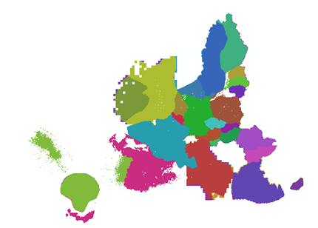

Due to the merging process double information in different grid cells were created:
- different member states (MS)
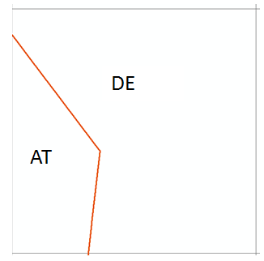

- different biogeographical regions (BR)
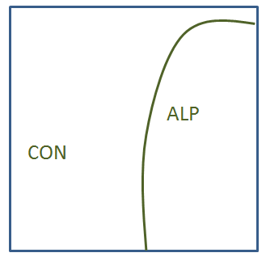
- different information about sensitive species
- different conservation status

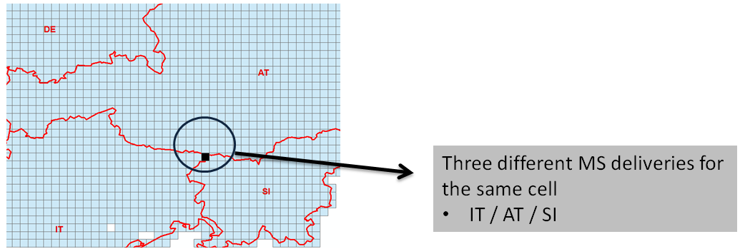
Figure 2-3 Example: double information for one cell

The final product only should not have double information in one cell. Therefore the double information has to be removed using the following RULE-SET.

Art17 Rules

When a single cell covers two or more different MS or BR an attribute allocation cannot be easily made. All cells with double information are flagged as [overlapping] =1:
New attribute:
[overlapping] =’1’ for conflict grid cells
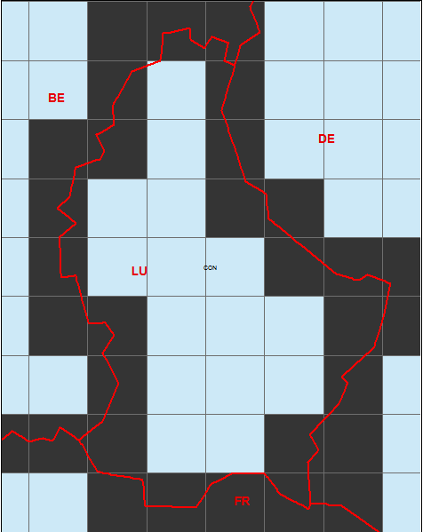 (black = conflict cells between LU;FR & DE)

- In case one MS has no information for this feature, the species or habitat code from the other MS (present in the cell) should be taken for the resulting map:
MS:  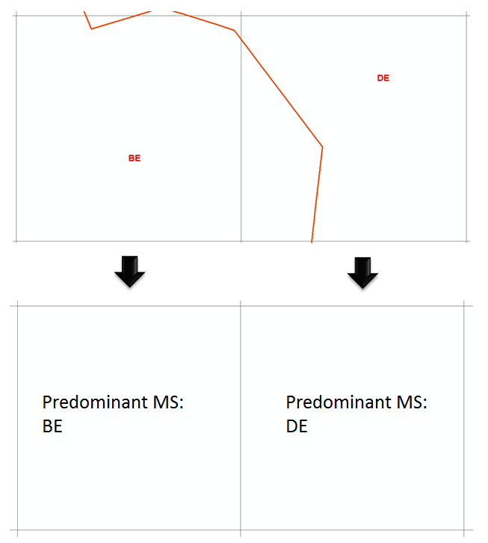 | 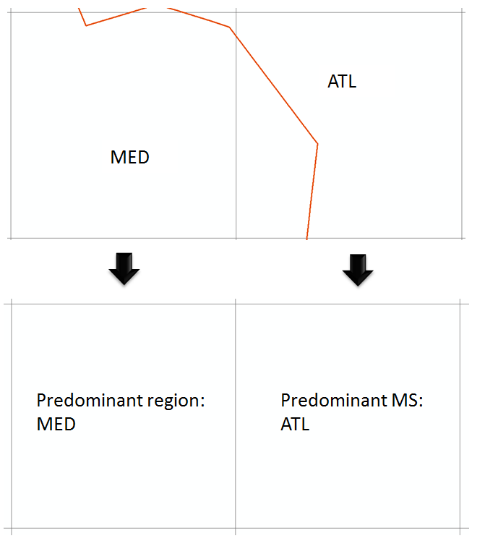  Biogeo.region:

- In case one MS/region has no habitat/species for this feature, the habitat/species from the other MS/region (present in the cell) should be taken for the resulting map
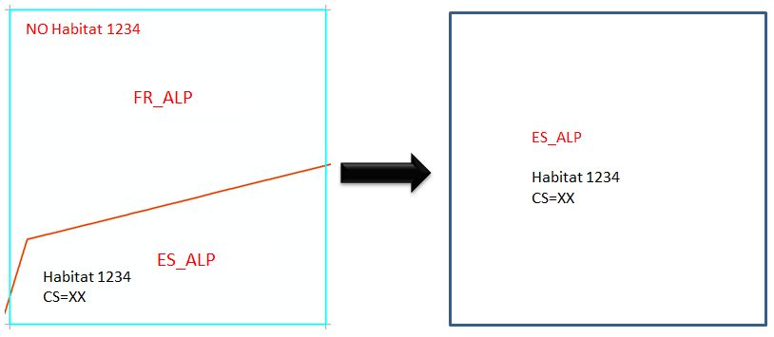

- In case of more than one assessment value (cs) for a feature in the conflicting cell the assessment value for this feature resulting from the MS/region with the largest proportion in the conflicting cell should be taken for the resulting map
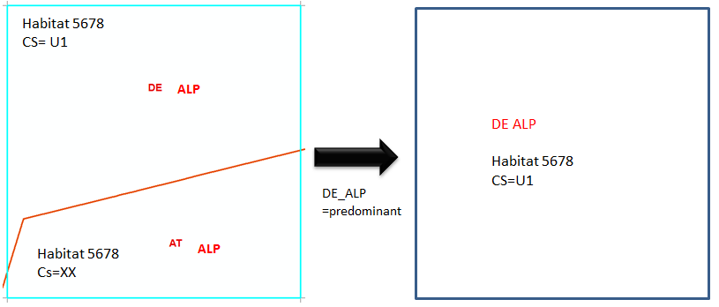
For one cell different CS values for habitat 5678 are reported from different MS.
- The attributes for the final cell will be taken from DE (the MS “DE” cover more area of the cell then the MS “AT”)

- In case one MS/region has no assessment value for this feature, the assessment value from the other MS/region (present in the cell) should be taken for the resulting map
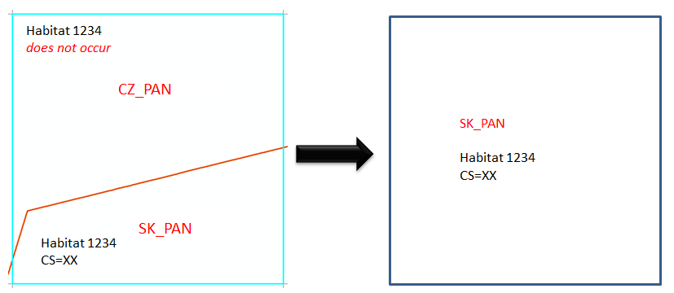
In case one MS/region has no assessment value for this feature, the assessment value from the other MS/region (present in the cell) should be taken for the resulting map

- In case of equal proportion of MS/region for a feature the worse assessment value should be taken (order XX,FV,U1+U1,U1-,U2+,U2,U2- where U2- is the worst).
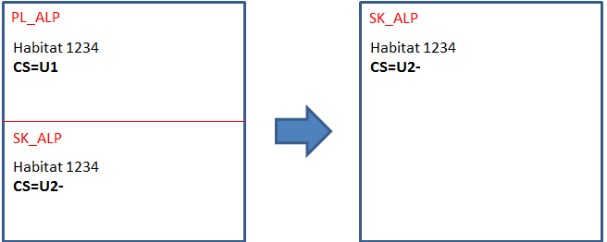
- in case of equal proportion of MS/region for a feature the worse assessment value should be taken (order XX,FV,U1+U1,U1-,U2+,U2,U2- where U2- is the worst)

- Rules for sensitive species

If a species is marked as sensitive, the distribution of the species will not be disclosed to the public by the Commission (for instance, by means of posting this information on a publicly available database or internet-based site). In some cases two different sensitivity information for the same species does exist.
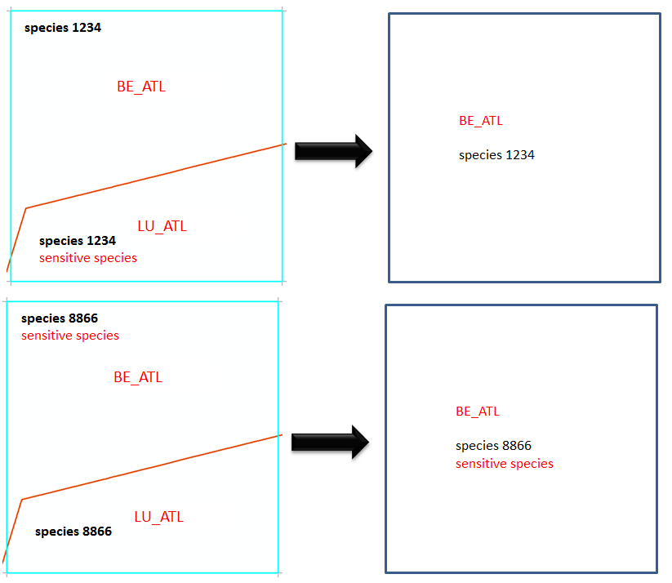
- If a predominant country flags a species as sensitive, the final species grid cell will be also flagged as sensitive.

- After the final EU Assessment, the EU-CS values were imported to the ART17 database. For the EU-CS values the country with the largest area inside a cellcode should be used for data joining. Therefore the EU-CS values were joined to the database using habitat/species-CODE and Major_MS. In some cases no information for EU-CS value was available inside the gridcell. In these cases the CS from the national assessment was used to fill the gaps.

Attributes of the European spatial data set
Habitats distribution
Attribute | Type | Example | Comment
CellCode | String | 10kmE429N265 | EEA 10 km grid code (ETRS3035)
EofOrigin | Number | 4290000 | East [m]
NofOrigin | Number | 2650000 | North [m]
GRIDS_CS | String | 10x10LAEA | Source GRID size
CATEGORY | String | Habiat | Habitat
MAPTYPE | String | Distribution | Maptype = DISTRIBUTION
CODE | String | 1170 | Art17 habitat CODE
MS | String | AT | Member state
Region | String | MATL | Biogeographical regions
CS_MS | String | FV | Conservation status by country
CS_EU27 | String | U2 | Conservation status by EU27
AREA_ha | Number | 10000 | Area in [ha]

Habitats range
Attribute | Type | Example | Comment
CellCode | String | 10kmE429N265 | EEA 10 km grid code (ETRS3035)
EofOrigin | Number | 4290000 | East [m]
NofOrigin | Number | 2650000 | North [m]
GRIDS_CS | String | 10x10LAEA | Source GRID size
CATEGORY | String | Habiat | Habitat
MAPTYPE | String | Range | Range
CODE | String | 1170 | Art17 habitat CODE
MS | String | AT | member state
CS_MS | String | FV | Conservation status by country
CS_EU27 | String | U2 | Conservation status by EU27
AREA_ha | Number | 10000 | area in [ha]

Species distribution
Attribute | Type | Example | Comment
CellCode | String | 10kmE429N265 | EEA 10 km grid code (ETRS3035)
EofOrigin | Number | 4290000 | East [m]
NofOrigin | Number | 2650000 | North [m]
GRIDS_CS | String | 10x10LAEA | Source GRID size
CATEGORY | String | Species | Species
MAPTYPE | String | Distribution | Distribution
CODE | String | 1078 | Art17 species CODE
CODE_old | String | 6199 | Art17 species CODE – as used by MS
MS | String | AT | Member state
Region | String | MATL | Biogeographical regions
CS_MS | String | FV | Conservation status by country
CS_EU27 | String | U2 | Conservation status by EU27
Sensitive | String | NO | sensitive (YES) / not sensitive (NO)
AREA_ha | Number | 10000 | Area in [ha]

Species range
Attribute | Type | Example | Comment
CellCode | String | 10kmE429N265 | EEA 10 km grid code (ETRS3035)
EofOrigin | Number | 4290000 | East [m]
NofOrigin | Number | 2650000 | North [m]
GRIDS_CS | String | 10x10LAEA | Source GRID size
CATEGORY | String | Species | Species
MAPTYPE | String | Range | Range
CODE | String | 1078 | Art17 species CODE
CODE_old | String | 6199 | Art17 species CODE – as used by MS
MS | String | AT | Member state
Region | String | MATL | Biogeographical regions
CS_MS | String | FV | Conservation status by country
CS_EU27 | String | U2 | Conservation status by EU27
Sensitive | String | NO | sensitive (YES) / not sensitive (NO)
AREA_ha | Number | 10000 | Area in [ha]

Explanation on criteria for the selection of reports and assessments which should be taken into account for statistics on conservation status

Please note: the following explanation is to provide some background information on the criteria for the selection of reports. The flag ‘use_for_statistics [yes/no]’ in the data table reflects these criteria.

Member State level

Depending on the purpose of the statistics certain habitats and species reports need to be excluded from the analysis in order to generate useful information. In principle the statistics on different aspects of conservation status should include habitats/species which:
- have a regular (and significant) occurrence in the Member State
- became extinct (probably extinct) after the Habitats Directive came into force in the Member State (for species)

The statistics should only include species for which the reporting is requested in the Reporting guidelines. Additional reports should be excluded.

Additional individual species reports for Cladonia spp. (subgenus Cladina), Lycopodium spp., Sphagnum spp. and Coregonus lavaretus Complex provided by some Member States should not be included in the statistics. The conservation status of these species is evaluated at the joint report done at the higher taxonomical level (at the genus level or at the level of species complex). Similarly for anadromous fish (with an exception of Acipenser sturio) reporting guidelines request Member States to provide reports only for terrestrial biogeographical regions. This report should cover both freshwater and marine stages of a life cycle. The reports for anadromous fish in marine regions should not be taken into account for statistics.

The reporting guidelines request the Member States to report also for habitats/species which do not have regular (and significant) occurrence in a Member State or in a region, but which:
- occurs occasionally in the biogeographical region or the number of specimens is insignificant (occasional species)
- do not represent a component of fauna of the biogeographical region, but which started to be observed recently (newly arriving species)
- occurs mostly in one region but with the distribution extending across the boundaries of the region to a neighbouring region in the same country (marginal habitats/species). In these situations member States provided a single report compiling information for both regions.

The reporting guidelines recommend also reporting for habitat and species
- which became extinct prior to the Habitats Directive came into force, especially if there is a reintroduction project (for species only)
- with uncertain ‘presence status’ (scientific reserve)
Member States indicated respective status of habitats and species in their Article 17 check-list, which was delivered as a part of the Article 17 report. The reported status was reviewed by the ETC/BD and major inconsistencies were corrected. However, there are still many inconsistencies in the use of status categories. For the sake of consistency a selective approach should be used for occasional, newly arriving species, species which became extinct prior to the Habitats Directive came into force and habitats and species with scientific reserve.

Occasional and newly arriving’ species
The Member States reports for ‘occasional’ and ‘newly arriving’ species in terrestrial biogeographical region should be included in the statistics if they contain the assessment of conservation status and if the occurrence of the species in the region is significant.

The Member States reports for occasional species in marine regions should be excluded, as available information does not allow distinguishing between situations where the conservation status is not assessed due to incomplete data or the assessment is impossible due to irregular occurrence of a species.

Species which became extinct prior to the Habitats Directive came into force.
The Member States reports for species which were marked as ‘extinct prior to the Habitats Directive came into force’ should be included in the statistics if they contain an assessment of the conservation status and there is either a reintroduction project, or the status is uncertain and the species can still be found back in future (and presence status ‘extinct prior to the Habitats Directive came into force’ is possibly incorrect).

Habitat and species with scientific reserve
The Member States reports for habitats and species with scientific reserve should be included in the statistics if they contain an assessment of the conservation status and/or an indication of a regular and significant occurrence of a habitat or species (and presence status ‘scientific reserve’ is possibly incorrect).

EU biogeographical level

On the EU biogeographical level the statistics should in principle include those biogeographical assessments, which contain at least one Member State report marked as ‘to include in the statistics’ at the Member State level, with an exception of several species listed below:

Leiostyla abbreviata | MAC | The species is endemic to Madeira. Its status was assessed as extinct prior to the Habitats Directive by Portugal and the evaluation of the conservation status was not done. The IUCN treats it as CR, as species still possibly persist in one of its potential localities.
Leiostyla gibba | MAC | See comment for Leiostyla abbreviata
Leiostyla lamellosa | MAC | The species is endemic to Madeira. Its status was assessed as extinct prior to the Habitats Directive by Portugal and the evaluation of the conservation status was not done. The IUCN treats it as EX, but stresses a possibility to find it again in future.
Jungermannia handelii | MED | The species was only reported by Spain as extinct prior to the Habitats Directive but the biogeographical assessment covers the populations in Greece.
Jungermannia handelii | ATL | The species was only reported by Spain as extinct prior to the Habitats Directive and the evaluation of the conservation status was not done. However scientists agree upon a possibility that the species could be found again in future and therefore it should not be treated as extinct.

For marine invertebrates, mammals and reptiles, all biogeographical assessments for species to be used for marine baseline should be included in the statistics (Recommendations on how to best incorporate HD Article 17 information in the MBA 2014 report). The reported information does not allow filtering out regional assessments for regions where these species occur irregularly.

