Annex 6

Description of sample task:
Lot 4 – Editing
Framework contract for the provision of communication services to EEA
Call for tender EEA/COM/10/001

1. Objective

An important element of the European Environment Agency’s (EEA) mandate is to make the environmental information it produces known, available and easily understandable to potential users. Achieving this demands professional editing of all texts aimed at external audiences. Not only is it vital to get the message across to the reader as effectively as possible, it is also important from a perceived credibility point of view that the language in all EEA products is correct.

The contractor providing editing services will be required to provide the following editing functions:

- Proofreading comprises checking spelling, grammar, syntax and correct usage of terminology; applying the EU Interinstitutional Style Guide; checking the accuracy and consistency of references throughout the document; and ensuring a consistent structure of chapters and sections.
- Editing includes all the elements in proofreading but also includes improving the structure, clarity and readability of the text by redrafting or reordering text; removing repetitions; querying ambiguities; and, where appropriate, suggesting the addition, deletion or restructuring of whole sections in order to convey the core messages more effectively.
To help evaluate the companies responding to Lot 4 of the above call for tender, bidders are requested to proofread and edit the text below as they judge to be appropriate.

Please use the track changes tool for easy detection of the introduced corrections and deliver the finished text as a printout.
Quality of life in cities

Nearly 80% of the Europeans live in big cities, smaller towns and in urban settlements around and between them. What does quality of life mean for Europe’s urban population? Some interviews shed light on it. As environmentalist we see a healthy environment as a basic condition enabling all the other requirements and wishes but why appears it so low on people’s agenda?

In fact the quality of life has improved a lot over the last decades and is high nowadays - more welfare, high car ownership, more living space per person, tourism, luxury goods. The environment has also improved in many parts; air quality levels improved as well as the quality of drinking water. People see their basic needs like a healthy environment fulfilled or just don’t percept problems there. A healthy environment becomes an implicitness, which does not come up immediately in their minds when they think about quality of life.

But environmental challenges are still present and new ones are on their way putting in question the achieved quality of life for the future. In some European cities this future already arrived. All over Europe the press reported when Barcelona had to order huge amounts of water delivered by ships in 2008 to serve its citizens and tourists. Other cities struggle with increased flood events or heat waves threatening the health of in particular elder and sensitive people. France, the Netherlands and Belgium were among the ten countries world wide reporting the most deaths caused by disasters in 2006. France registered 1.400 deaths, the Netherlands 1000 and Belgium 940 due to the heat wave in July.

70% of the EU citizens experience too high noise levels in cities. Mostly households with lower income live in the city areas with a poorer environment. They need affordable apartment prices and find them there. They often cannot afford a car and dependent on public transport in any case. They are not able to escape the situation by moving out like higher income households do, who add even more noise and air pollution to the poor quarters by driving through to their green and quiet suburbs. Even if we achieved generally a high quality of life in Europe not everybody lives in a healthy environment. It depends still on people’s income if they have the choice.

Cities need to cope with these challenges in order to ensure a high quality of life for all their citizens and future generations. Apart from the topographic situation it is also the urban design which increases the effects of heat waves in cities like Zaragossa. Besides low rainfalls over month also urban sprawl, inappropriate infrastructure and rising consumption of water may have substantially contributed to the water problem of Barcelona and other cities. It gives a taste of the future under changed climate conditions if cities do not adapt in time. However, cities are not at the mercy of these challenges; they and their citizens are part of them.

Back until their foundation towns and cities depended on the services of their hinterland - food, fresh water, building material etc. Nowadays European cities depend even more on the services of not only their hinterland but also many other regions of Europe and the world. We send bottled water from one corner in Europe to another, get our apples from New Zealand, and clothes from China. However, cities act differently. The ecological footprint - indicating how much land and water area an individual, city or country requires to produce the resources it consumes and to absorb the waste it produces - shows how much cities not only depend but also impact other regions and therefore the quality of live in whole Europe and other parts of the world. In 2000, the ecological footprint of Greater London, UK, was calculated with 49 million gha, which was 293 times its geographical area or twice the size of the UK. If everybody in the world would have the footprint of a Birmingham citizen we would consume the area of 2.9 planets. It would be even 3.2 planets if everybody follows Edinburgh’s way of life.

As nearly 3700 people per square km live in Birmingham and only 1700 in Edinburgh it indicates that urban sprawl, the low density expansion of large urban areas, is crucial to the environmental performance of cities besides housing conditions and food consumption. Urban sprawl increases transport demands (figure 1), requires more but low used water and wastewater infrastructure and the mostly detached houses need more energy to be heated than flats in apartment buildings. Together with the upgraded and new roads sprawl takes land, fragments landscapes and affects thus biodiversity and ecosystem services on which we depend - like the supply of sufficient and high quality water.

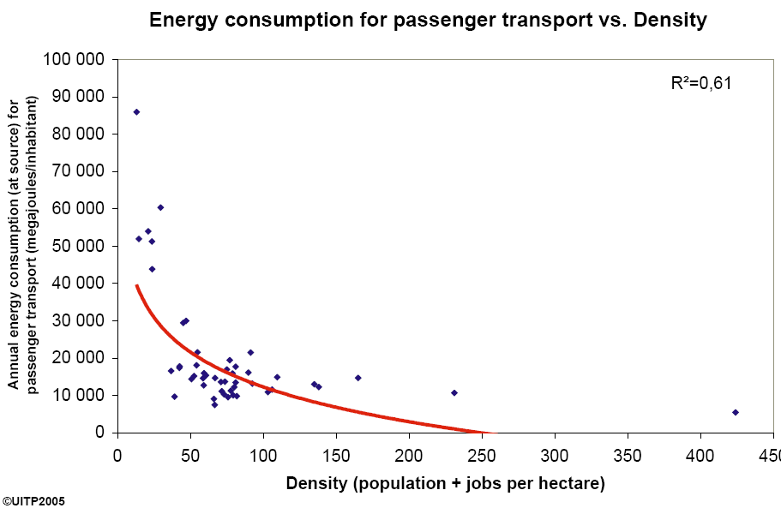

Figure 1
Source: UITP Database Mobility in Cities

In turn the soil sealing map of e.g. Tirana (Albania) shows clearly that urban sprawl is driven by transport infrastructure (figure 2). The city is still relatively compact and dense, but spreads along major transport lines. Ones accessibility will further improve and car ownership from currently only around 50 cars per 1000 persons will rise to the ten times higher Western-European levels further massive sprawl increasing again the transport demand can be expected not only around Tirana but also other South Eastern European and Eastern European cities if not suitable managed.

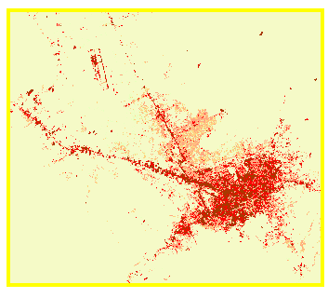

Figure 2: soil sealing in Tirana (Albania) 2006

The level of urbanization and soil sealing is different across Europe –from below 2% in countries like Albania and Macedonia but also Estonia and LV and above 8% like the Netherlands, Belgium and Malta with more than 15% (figure 3). One could argue the first group of countries perform better, but the relation to population figures shows that some highly sealed countries like the Netherlands or Malta use only between 100 and 250 square meter per capita meanwhile lowly sealed countries like Estonia have around 450 square meters per capita (figure 4). Although the rate of soil sealing cannot be put on a level with urban sprawl, as the economic and transport structure plays a role, the differences indicate potentials to limit sprawl.

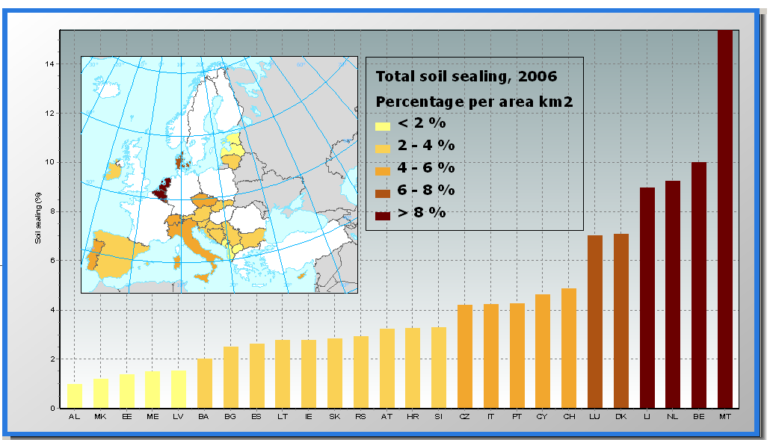

Figure 3

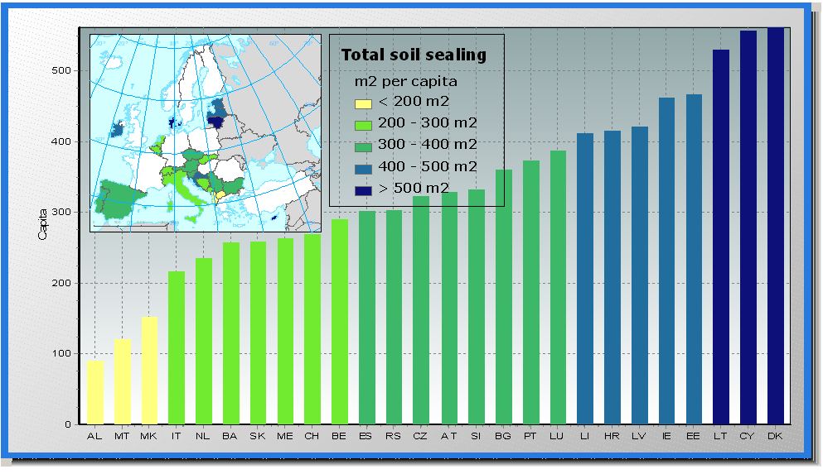

Figure 4

As cities are part of the challenges they have in cooperation with national and European governments also the solutions in their hand. An appropriate urban design – compact cities enabling an effective public transport, safe walking and cycling, offering sufficient and high quality public and green space - can reduce the ecological footprint of cities and improve the environment without reducing economic, social and cultural activities. New technologies and building design facilitate to increase the energy efficiency of buildings. Information communications technology like e-services can help to avoid transport but sustain the mobility of people.

Our current way to act and live led to a high quality of life in most parts of Europe. However, not everybody can experience even the basics like a healthy environment and if we proceed our way we risk the quality of life of future generations and of people somewhere else in the world. The rise in the quality of life in cities over the past 50 years has created increasing pressures on the environment arising from the growing consumption associated with this new quality of life in cities. Uncovering and breaking the current mismatch of popular short term conceptions of quality of urban life and the longer term needs for environmental sustainability as well as keeping and eye on new challenges and processes like an aging population, immigration, social segregation will be a key issue in urban governance at local as well as from the national and European level.

http://www.em-dat.net/documents/CRED%20CRUNCH%208%20-%20March%2020071.pdf
http://www.citylimitslondon.com/;
Footprint data: http://www.wwf.org.uk/oneplanet/cf_0000004481.asp,
population data: urban audit database 1999-2002 (Eurostat)

